**Testing–4**

**Postman 4.1**

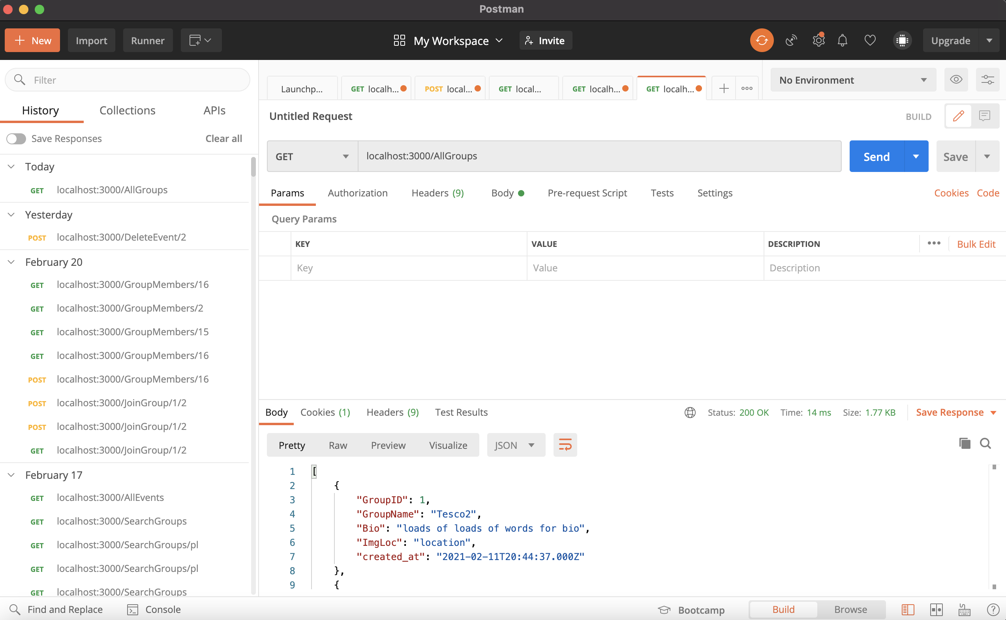

To do a lot of the API testing I used an application called Postman. This tool lets you send and receive a request from a service. It was a very useful tool as it let me check to make sure my API worked before using it in my code. Another reason why it was useful was because if there was an error in my code, I wouldn’t know whether it was the API or the Ajax call that was incorrect. But by checking postman it let me know that the API was either sending the right information or not narrowing down where the error in my code was.

The UI was very easy to use and it let me change from GET, POST and PUT letting me test any API I could've possibly used. It also let me input a body to test when passing through a username for example to ensure that it would work with a user’s input.

**Test Strategy 4.2**

In order to make sure the system works I will be testing it. This will include testing that the game functions properly (black box testing) and testing the user interface (eg. Buttons, input boxes) with white box testing.

To test the input fields, I will use valid and erroneous data to check that the system can handle them properly and not crash.

I will be recording on QuickTime Player.

|  |  |  |  |  |  |
| --- | --- | --- | --- | --- | --- |
| # | Description of test | How to test/ test data used | Expected outcome | Actual outcome | Time stamp |
| 1 | Test if registering an account works | Testname – username  123 – password  Then press register | Notification of successful register. Check sql users table to make sure | Success: user has been successful registered |  |
| 2 | Test login if wrong username but correct password creates an error | Testname1 – username  123 - password | Notification of incorrect password or username. Shouldn't be redirected to profile page | Success: Notification of incorrect password or username. |  |
| 3 | Test login if correct username but incorrect password creates an error | Testname – username  1234 - password | Notification of incorrect password or username. Shouldn't be redirected to profile page | Success: Notification of incorrect password or username. |  |
| 4 | Test login with correct password and username | Testname – username  123 - password | User should be redirected to their profile page | Success: User has been redirected to the profile page |  |
|  | **Profile Page** |  |  |  |  |
| 5 | Test to see if the profile is the accounts profile | The box under the “MyProfile” will display the username of the account | Box should display the username that the user logged in with. | Success: box displays username that the user logged in with |  |
| 6 | Test to see if the cookie has been created for the UserID | I will check the console log for the UserID in the cookie showing the code as well. | Console should log the correct UserID from the cookie | Success: correct UserID has been logged |  |
| 7 | Test to make sure user cannot edit text without clicking edit button first | Click on the box and try to type. | Won't be able to type and change the information in the box. | Success: user cannot change the data in the boxes |  |
| 8 | Test to see if edit button makes text boxes editable | Click on the edit button | All the boxes will no longer be greyed out and can be edited. | Success: when the button is clicked the boxes are editable |  |
| 9 | Test to see if when changed data is saved it updates the database and page | Change the data then press the save button then reload the page to prove it has updated the database | When the page is reloaded the data in the boxes should be the same as what they’ve been changed to. | Success: when the page is reloaded the new data remains in the boxes |  |
| 10 | Test to see if the close button works | Click on the close button | Should turn the boxes to grey again and they can no longer be edited | Success: the boxes cannot be edited anymore and are grey |  |
| 11 | Test to see if the log out button returns user to the login/register page | Click log out button | User should be redirected to the login/register page | Success: the user is now on the login page |  |
| 12 | Test to see if the log out button deletes the cookie | Check console log | Console log should say if the cookie has been deleted | Success: console log shows that the cookie has been deleted |  |
| 13 | Test to see if the delete button returns user to login/register page | Click the delete button | User should be redirected to the login/register page | Success: the user is now on the login page |  |
| 14 | Test to see if the delete button deletes the account | Check sql table for the account | The account should no longer be on the Users table | Success: the account has been deleted and is no longer on the Users table |  |
| 15 | Test to see if the delete button deletes the cookie | Check console log | Console log should say if the cookie has been deleted | Success: console log shows that the cookie has been deleted |  |
| 16 | Test to see if the button with the 3 lines brings the pull-down menu up | Click the button in the top right corner | Pull-down menu should appear | Success: Pull-down menu appears |  |
| 17 | Test to see if going to the calendar works | Click MyCalendar | User should be redirected to the calendar page | Success: user was redirected to the calendar page |  |
|  | **Calendar Page** |  |  |  |  |
| 18 | Test to see if the calendar shows the current day | Open new tab to search for current day | The red box should be over the current day | Success: the red box highlights the current day |  |
| 19 | Test to see if the arrows go back and forward a month | Click on both arrows | The month should go back and forth | Success: the month goes back and forth |  |
| 20 | Test to see if the year can change | Click on the arrows until the year changes | The year should increase or decrease depending on which way you went | Success: the year changes |  |
| 21 | Test if the groups button works | Click groups button | Groups page should load up | Success: groups page is loaded up |  |
|  | **Groups Page** |  |  |  |  |
| 22 | Write a groups name in the search box that won’t bring anything up | Type aaa then press search | The table should display no groups | Success: the table displays no groups |  |
| 23 | Test if the reset button works | Press the reset button | The page should reload and all the groups are displayed again | Success: page is reloaded and all the groups are displayed again |  |
| 24 | Test if the search function works | Search “Tes” then press search | The table should display all groups who's group name begins with tes | Success: all groups beginning with tes are displayed |  |
| 25 | Test if when searching for the whole name of a group it goes to their page | Search “tesco2” | User should be redirected to the tesco2 group page | Success: user was redirected to the tesco2 group page |  |
| 26 | Test if a cookie has been created for the GroupID of whatever the user searched | Check the console log then show the code | Cookie should be created for the groupID of the group the user searched for | Success: cookie was created with the same ID as the group the user searched for |  |
| 27 | Test if create group button redirects to group page | Press button | User should be redirected to group page of this new group | Success: user is redirected to the new page |  |
| 28 | Test if create group button creates a new group | Check group table before and after clicking the button | A new group should be created | Success: new group has been created |  |
|  | **Group Page** |  |  |  |  |
| 29 | Test to make sure user cannot edit text without clicking edit button first | Click on the box and try to type. | Won't be able to type and change the information in the box. | Success: user cannot change the data in the boxes |  |
| 30 | Test to see if edit button makes text boxes editable | Click on the edit button | All the boxes will no longer be greyed out and can be edited. | Success: when the button is clicked the boxes are editable |  |
| 31 | Test to see if when changed data is saved it updates the database and page | Change the data then press the save button then reload the page to prove it has updated the database | When the page is reloaded the data in the boxes should be the same as what they’ve been changed to. | Success: when the page is reloaded the new data remains in the boxes |  |
| 32 | Test to see if the close button works | Click on the close button | Should turn the boxes to grey again and they can no longer be edited | Success: the boxes cannot be edited anymore and are grey |  |
| 33 | Test to see if the delete button returns user to groups page | Click the delete button | User should be redirected to the groups page | Success: the user is now on the groups page |  |
| 34 | Test to see if the delete button deletes the group | Check sql table for the group | The group should no longer be on the groups table | Success: the group has been deleted and is no longer on the groups table |  |
| 35 | Test to see if the delete button deletes the cookie | Check console log | Console log should say if the cookie has been deleted | Success: console log shows that the cookie has been deleted |  |
| 36 | Test to see if the events button works | Click events | User should be redirected to events | Success: user is redirected to events |  |
|  | **Events Page** |  |  |  |  |
| 37 | Write a events name in the search box that won’t bring anything up | Type aaa then press search | The table should display no events | Success: the table displays no events |  |
| 38 | Test if the reset button works | Press the reset button | The page should reload and all the events are displayed again | Success: page is reloaded and all the events are displayed again |  |
| 39 | Test if the search function works | Search “Tes” then press search | The table should display all groups whose event name begins with tes | Success: all events beginning with tes are displayed |  |
| 40 | Test if when searching for the whole name of a group it goes to their page | Search “meeting” | User should be redirected to the meeting event page | Success: user was redirected to the meeting event page |  |
| 41 | Test if a cookie has been created for the EventID of whatever the user searched | Check the console log then show the code | Cookie should be created for the EventID of the group the user searched for | Success: cookie was created with the same ID as the event the user searched for |  |
| 42 | Test if add event button redirects to group page | Press button | User should be redirected to event page of this new group | Success: user is redirected to the new page |  |
| 43 | Test if add event button creates a new event | Check event table before and after clicking the button | A new event should be created | Success: new event has been created |  |
|  | **Event Page** |  |  |  |  |
| 44 | Test to make sure user cannot edit text without clicking edit button first | Click on the box and try to type. | Won't be able to type and change the information in the box. | Success: user cannot change the data in the boxes |  |
| 45 | Test to see if edit button makes text boxes editable | Click on the edit button | All the boxes will no longer be greyed out and can be edited. | Success: when the button is clicked the boxes are editable |  |
| 46 | Test to see if when changed data is saved it updates the database and page | Change the data then press the save button then reload the page to prove it has updated the database | When the page is reloaded the data in the boxes should be the same as what they’ve been changed to. | Success: when the page is reloaded the new data remains in the boxes |  |
| 47 | Test to see if the close button works | Click on the close button | Should turn the boxes to grey again and they can no longer be edited | Success: the boxes cannot be edited anymore and are grey |  |
| 48 | Test to see if the delete button returns user to events page | Click the delete button | User should be redirected to the events page | Success: the user is now on the events page |  |
| 49 | Test to see if the delete button deletes the event | Check sql table for the event | The account should no longer be on the groups table | Success: the group has been deleted and is no longer on the groups table |  |
| 50 | Test to see if the delete button deletes the cookie | Check console log | Console log should say if the cookie has been deleted | Success: console log shows that the cookie has been deleted |  |

Link for the video:

https://youtu.be/QYSyO7jYakQ